**‘Care Share**



January 2022

**Fraud in Hospice Care**

Hospice fraud is largely unreported and can cause direct patient harm if undetected.

Hospice care is comfort care at the end of life. It focuses on managing pain to provide a higher quality of life for terminally ill individuals and provides support and counseling for their caregivers and family members.

Hospice is a much-needed benefit with most providers dedicating their careers to compassionate care for those at the end of their life. However, even a small percentage of fraud can cause incalculable harm. To understand the scope, here are three cases referred for investigation to the Office of Inspector General from California SMP.

**Case No. 1: Beneficiary Loses Access to Medication**

In this case, a person on Medicare was unable to access her medication at the pharmacy. She learned the pharmacy put a hold on her prescription because she was enrolled in hospice. She was not terminally ill, nor was she aware that she was enrolled in hospice. When SMP interviewed her, she claimed that a nurse came to her home offering housekeeping services “covered by Medicare.” While that “benefit” sounded good, she signed up but had no understanding that she was actually signing up for Medicare’s hospice benefit.

**Case No. 2: Medicare Stops Paying Beneficiary’s Medical Bills**

In another case, a beneficiary became concerned when Medicare stopped paying many of his medical bills. SMP researched his case and found that he had been enrolled in hospice. He was not aware of this, and unlike case no. 1, no nurse or hospice representative called or came to his door. He believes his Medicare number was stolen and used to enroll him into hospice without his consent.

**Case No. 3: Fraudulent Hospice Enrollment Causes Beneficiaries’ Health Decline and Death**

The son of an elderly man on Medicare received a call from a nurse one day who said his father qualified for hospice because of his age. She promised his dad would enjoy access to even more Medicare benefits and that the program would coordinate with his dad’s primary care doctor. But this did not happen. After enrolling in hospice, the father’s health declined rapidly. The hospice company changed his medications and told him not to go to his doctor of the emergency room.

The son watched his father’s health decline and wasn’t sure what to do. When his father was no longer eating or able to use the bathroom, the son took him to the emergency room. Weeks later, his father died.

Whether it’s financial harm from fraudulent billing, medical identity theft, or misrepresenting hospice medical care benefits,

these few stories of hospice fraud illustrate the resulting harm to patients. There are several fraud schemes commonly seen in hospice to be aware of.

**Medically Unnecessary Services**

Some unscrupulous providers target beneficiaries who may live far longer than six months to maximize reimbursement. Others falsely diagnose patients with terminal illnesses, causing significant emotional distress and financial harm.

**Fraudulent Marketing**

In some cases, they may target vulnerable individuals with dementia, the homeless, or the illiterate to convince them to enroll in hospice. In others, they may attempt to convince individuals that Medicare no longer requires a terminal diagnosis or includes non-covered services such as housekeeping or free groceries. Some simply steal medical identities to enroll patients in hospice.

**Kickbacks**

Physicians deceitfully accept kickbacks to make patient referrals to hospice facilities or have hidden ownership in the hospice agency to which they refer. They may also accept lucrative and above fair market value positions as hospice medical directors. Nurses, medical assistants, and even company executives can be involved in kickback schemes.

**Billing for Services Not Rendered**

Patients may be subjected to neglect, poor quality of care, and being billed for services not rendered. Because hospices get reimbursement from Medicare not whether the hospice provider visited the patient daily but by a per diem rate, some hospices are tempted to maximize profit through inadequate staffing.

**Misrepresentation**

Dishonest hospice agencies may falsely bill for a higher level of care than was needed or provided.

The SMP recommends that beneficiaries should:

• Be sure their doctor has assessed their condition.

• Be sure their doctor has certified that they are terminally ill and expected to live six months or less if the disease runs its normal course.

• Never accept gifts in return for hospice services and be wary of “too-good-to-be-true” offers.

• Report quality-of-care complaints to their local SMP and the Beneficiary and Family Centered Care Quality Improvement Organization (BFCC-QIO) (qioprogram.org/file-complaint).

In Dr. Atul Gawande’s book titled Being Mortal: Medicine and What Matters in the End, he states, “We’ve created a multitrillion-dollar edifice for dispensing the medical equivalent of lottery tickets – and have only the rudiments of a system to prepare patients for the near certainty that those tickets will not win.” Dr. Gawande goes on to discuss how the hospice concept developed, and the spectrum from remarkable compassion to patient harm that currently exists in today’s end of-life care.

Please read the Medicare Summary Notice and report all suspicions of hospice fraud to MT SMP at 1-800-551-3191.

*Excerpts taken from Medicare Messenger, September 2019, and March 2020.*

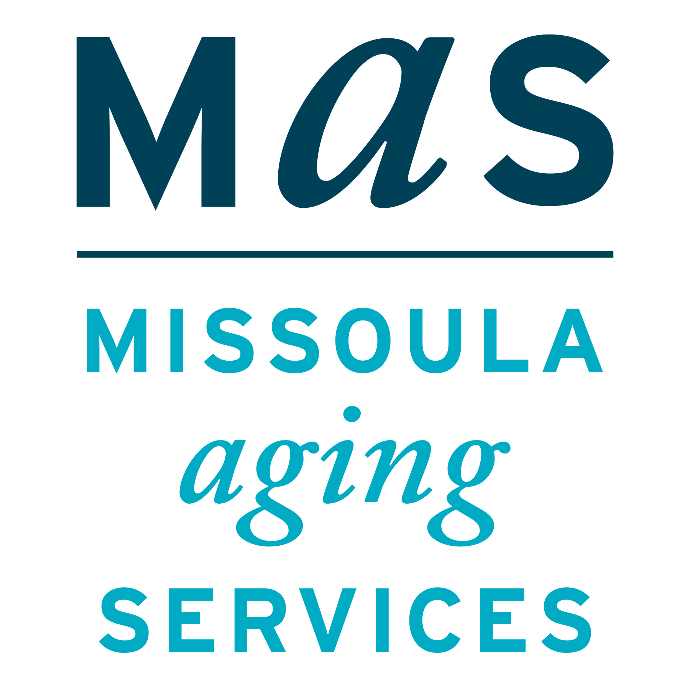



Montana SMP is a program coordinated by Missoula Aging Services and partnered with local Area Agencies on Aging. This project was supported by grant #90MPPG0052 from the U.S. Administration for Community Living, Department of Health and Human Services, Washington D.C., 20201. Points of view or opinions do not necessarily represent official ACL policy.

# CMS Encourages People with Medicare to get COVID-19 Vaccine Booster Shot

As part of the Biden-Harris Administration’s ongoing efforts to ensure that Americans are vaccinated against COVID-19 and to reduce stress across the nation’s health care system, the Centers for Medicare & Medicaid Services (CMS) is encouraging those with Medicare who are fully vaccinated to get a booster dose of the COVID-19 vaccine. Data shows that a COVID-19 vaccine booster does increases immune response, which improves protection against COVID-19. People with Medicare pay nothing when they get the COVID-19 vaccine and booster and there is no applicable copayment, coinsurance, or deductible.

The Senior Medicare Patrol (SMP) helps to educate Medicare beneficiaries about ways to prevent, detect, and combat Medicare fraud. For more information about Medicare fraud, visit the Stop Medicare Fraud website at www.stopmedicarefraud.org.

